Name:  Class: | ____________________________________  ________________ |  | Date:_________
 | Year 10A Test 6 2021  SCORE:  /52  Topic: Logarithms and Data
Total Time: | 50 Minutes
Weighting: | 5%
Equipment: | To be provided by the student: Pen, pencil, ruler, scientific calculator, Interactive notebook

- Rewrite these exponents as Logs: [3 marks]
- 4^{x} = 32

- x⁵ = 25

- 12³= x

- Evaluate using base 10 Log [6 marks]
- log (20) + log (2) + log (25)

- log (42) - (log (6) + log (7))

- Evaluate these logarithms [8 Marks]
  - log4 (64)

  - log13 (1)

  - log5(625)

  - log10(1000000)

  - log5(0.2)

  - log27(3)

- Find the value of x [4 marks]
- $20×1.2^{x}=40$

- $4×1.5^{x}=20$

- Solve the following log [3 Marks]
  - 6Log₆(36) – 3log₆(216)

  - 3 log₁₈ (3) + log₁₈ (6) – log₁₈ (9) - log₁₈ (18)

  - $\frac{1}{2}$ log₃ (9) + 2 log₃ (3)

- Given the following data, find the following for the given data set. [4 Marks]
Stem | Leaf
0 | 3 4 5
1 | 0 1 1 2
2 | 4 5 6 8 9
3 | 0 1 2 4 6 7
Mean: Median: Mode:
- Determine the interquartile range for this data set: 5, 8, 13, 17, 18, 22, 24 [2 marks]

- Find the standard deviation of the following data set: 22, 26, 27, 29, 33 [2 marks]

- Given the Data below, Construct a scatterplot, and draw a trend line for the data. [3 marks]

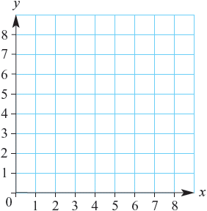
x | 2 | 3 | 6 | 4 | 5
y | 4 | 6.5 | 6 | 3 | 8

- Comment on the scatterplot below. [3 Marks]
Hours spent working

Age

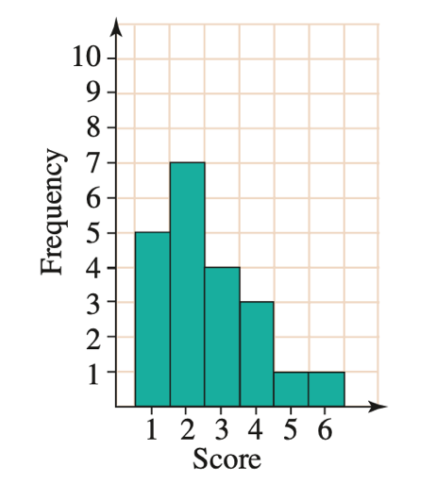
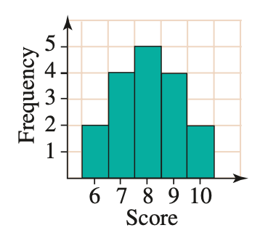
- Comment on the shape of the following graphs [4 marks]

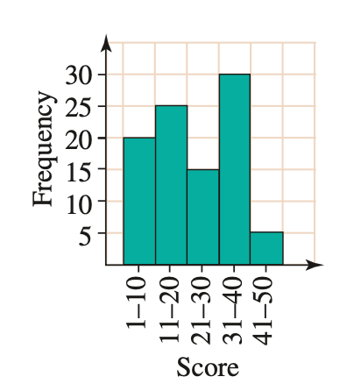
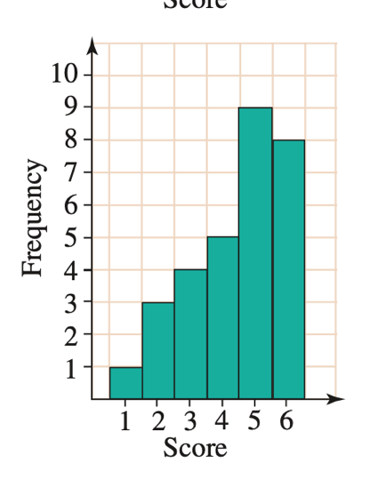

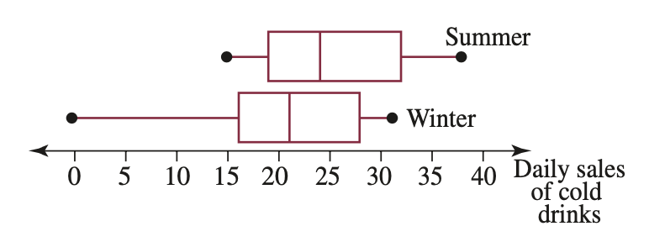
- The stacked box plots below show the number of drinks sold in summer and winter on average. Comment on the distribution of both data sets. [6 marks]

